Call Committee Process FAQs
September 2020

Q: It has been a long time since our congregation discussed what we need in a pastor. Can you help refresh my memory?
A: Shortly after Pastor Jon departed, our congregation began praying and discussing what our church needs in its next pastor. Listening Post sessions, surveys and congregational meetings took place throughout 2019 inviting folks to voice the wants and needs of our congregation. Those requests were gathered by the Transition Team, who drafted a 15-page document called our Ministry Site Profile. That profile served as our church’s resume, so-to-speak, and helped prospective pastoral candidates get to know us. You may read an abbreviated version of the MSP document here.
Q: We are in the middle of a pandemic, and so much has changed since the MSP was written. Is it still valid to use that document to search for a pastoral candidate?
A: Absolutely! Our MSP is still valid and pertinent to who God is calling us to be in our community and what our needs are in the next chapter of ministry. The pandemic has changed a lot about how we engage at church and with each other, but it does not change our desire to attract and educate young adults, to address the aging north end of our building, to establish a solid administrative foundation for our ministries and to revitalize our church so that we can become an even greater source of outreach and care in our community.
Q: I thought we were trying a co-pastor model, but I see the Call Committee has chosen a pastor who will serve as a solo, full-time pastor. Why the change?
A: As you may recall, the congregation weighed in on our next pastoral model through a survey distributed last January. The results are pictured below. Because the congregation was roughly split in its preference, the Executive Team empowered the Call Committee to determine the pastoral model. The synod was aware of this unique circumstance and gathered pastoral candidates who were willing to consider different pastoral model options. The Call Committee decided that they would prioritize first who the best candidate is and why they would be a good fit, and allow the pastoral model to be decided as a secondary consideration. Furthermore, our budget was limited to an amount that would support either two part-time pastors or a full-time solo pastor. The Call Committee felt a solo, full-time pastor could be competitively compensated and provide focused attention to our church family and its needs.
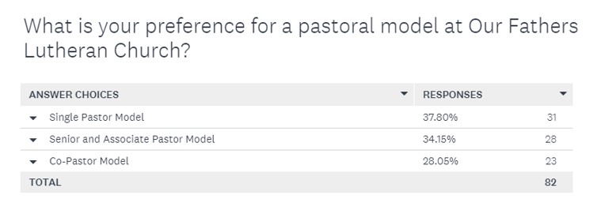
Page 1 of 3

Q: Pastor Cathy has already been called. Why is her call currently in question?
A: The congregation approved a specific 18-month term call allowing Pastor Cathy to become ordained. That call was never a permanent call. Since then, she has signed contract extensions to continue providing bridge support to Our Father’s. The congregation approved the formation of a Call Committee at the 2019 Annual Meeting so that a permanent pastoral solution could be discerned. Cathy’s contract states that her call will end when another pastor is called, and she was made aware of this through conversations with OFLC leadership and the synod when she entered the call process as an internal candidate.
Q: What happens to Pastor Cathy if the congregation votes “yes” to approve Pastor Aaron’s call?
A: Pastor Cathy is also currently serving as part-time pastor at House of Grace. If our congregation votes to call Pastor Aaron, Cathy is contractually guaranteed her position at Our Father’s through November 3.

Q: Why was Pastor Cathy dismissed so abruptly in early September?
A: Pastor Cathy was notified that she was not the final candidate and was invited to process that news at her own pace. The reality that our internal candidate did not possess the best skills and experience to lead in this next season was difficult and emotional for everyone. Cathy chose to use a combination of vacation time and a leave of absence to be away from OFLC until the congregational vote on October 4. Lay leaders have graciously volunteered to perform all pastoral tasks during her absence.

Q: Why was Pastor Aaron chosen by the Call Committee?
A: Of the seven candidates considered, Pastor Aaron Fuller was chosen by the Call Committee because of his extraordinary experience and aptitude to help Our Father’s move into the next chapter of ministry. He is incredibly bright, insightful, creative, and well-prepared to meet the challenges of our youth education gap, our building project, our administrative inefficiencies and to serve as a strong, caring, relational leader. Learn more about Pastor Aaron on the OFLC website.

Q: If the Call Committee and Council have already agreed that Pastor Aaron should be our next pastor, why does the congregation need to vote?
A: Synod guidelines and our constitution require a call process to be finalized with three levels of congregational approval: First, the Call Committee lifts up its final candidate. Second, the Council needs to learn about and vote to approve the Call Committee’s recommendation. Finally, members of the congregation vote whether to approve the pastoral candidate being lifted up by leadership.

Page 2 of 3
Q: When can I vote?
A: Voting members of our congregation are encouraged to cast their ballot on Sunday, October 4 between 10 a.m. and noon. This will be a safe, socially-distant process that will proceed as follows:
- When you arrive at the church’s north parking lot, a member of leadership will register you to vote using a laptop. You will stay in your car to do this.
- You will then be given a paper ballot that looks like this:
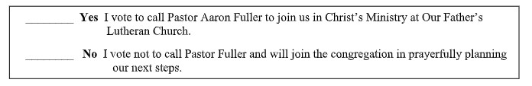
- You may find a parking spot and fill out your ballot.
- Once you mark your ballot, you can drive to a collection box in the parking lot to submit your anonymous vote. Votes will be counted by the Counting Team. Results will be announced at church by 12:30 p.m. and an email will be also distributed to share the outcome.

Q: Are absentee votes being accepted due to COVID-19?
A: Yes! If you are unable to vote in person at church on October 4, call the church office at
763-477-6300 and leave a message with your name, phone number and address to request a “home vote.” A member of the Executive Team will contact you to make arrangements to deliver a ballot and wait while you vote. After you fill out your ballot, you will be asked to seal it in an envelope and print your signature over the seal. Your ballot will then be added to the ballot box and be tallied by the Counting Team on October 4.

Q: What are the potential outcomes of the Oct. 4 vote?
A: There are two potential outcomes on October 4:
- If the majority of voters cast a “yes” ballot to call Pastor Aaron Fuller, he will be called to join Our Father’s Lutheran Church as our solo, full-time pastor. Pastor Cathy’s call at OFLC will then come to an end.
- If the majority of voters cast a “no” ballot, this Call Committee’s process has ended. The congregation would need to prayerfully consider next steps and recruit a new Call Committee into the discernment process.
Q: What should I do before the October 4 vote?
A: Take time to visit the church website to learn more about the call process and learn about Pastor Aaron so you can cast an informed vote. Finally—and most important—PRAY! A prayer guide has been created to help you seek God’s guidance through prayer, scripture, and meditation. Please set aside some quiet time before October 4 to connect with God about this important time in our church’s history.
Page 3 of 3

